Second regular session 2013
9 to 13 September 2013, New York
Item 3 of the provisional agenda
Financial, budgetary and administrative matters

Annual review of the financial situation, 2012

Report of the Administrator
Summary
The present report provides an overview of the financial position of UNDP and UNCDF at the end of 2012 on the basis of International Public Sector Accounting Standards, which were adopted on 1 January 2012. As previous reporting was presented on the basis of United Nations system accounting standards, comparisons with prior years are presented for illustration only.
Total UNDP revenue in 2012 declined slightly, to $5.09 billion (2011: $5.37 billion), of which voluntary contributions were $4.74 billion (2011: $4.94 billion). Total expenses in 2012 were $5.26 billion (2011: $5.52 billion), remaining above the level of total revenue by drawing upon the accumulated surplus from previous years.
Voluntary contributions to regular resources totalled $846 million (2011: $975 million), although additional contributions equivalent to $49 million relating to 2012 were received, and will be recorded as revenue, in 2013. UNDP expenses related to regular resources were $1.03 billion (2011: $0.98 billion).
Total other resources voluntary contributions revenue (cost sharing, trust funds, reimbursable support services and miscellaneous activities) in 2012 amounted to $3.98 billion, which, after transfers, refunds and other adjustments, was reduced to $3.86 billion (2011: $3.96 billion).
The contributions revenue of $3.98 billion comprised funding from programme country governments and local partners, including the private sector, of $0.93 billion (2011: $0.89 billion); bilateral partners, $1.41 billion (2011: $1.59 billion); and multilateral partners, $1.55 billion (2011: $1.54 billion); and other amounts of $0.09 billion (2011: $0.09 billion). Other resources expenses amounted to $4.43 billion (2011: $4.74 billion), remaining above the level of total contributions.
UNCDF revenue totalled $55 million. Contributions revenue grew to a record level of $55 million in 2012 (2011: $50 million), due entirely to continued growth in its other resources. Total expenses totalled $51 million, which included $48 million for development activities (2011: 50 million).
Despite the challenging environment and late receipt of contributions, at the end of 2012 UNDP maintained a year-end liquidity position of approximately 3.71 months of working capital – within the minimum threshold of liquidity requested by the Executive Board.
As a consequence of the adoption of International Public Sector Accounting Standards, UNDP recognized its full liabilities within its balance sheet, resulting in total adjustments that reduced net assets by $149 million. After the adjustments, the balance sheet continued to have a positive net assets position.
Other resources comprise an important complement to the regular resource base. Whereas both fell in 2012, the ratio of regular to other resources declined by 1 per cent, to 82 per cent and 18 per cent respectively. The ability of UNDP to fulfill its multilateral mandate is contingent on a viable mix of predictable regular and other resources, in which sufficient untied regular resources enable UNDP to plan ahead, be strategic and responsive, and provide predictable, differentiated services across programme countries, particularly the poorest and most vulnerable.
UNDP coordinates the United Nations system at the country level and plays a vital role in forging development coherence. The value of fund-flows to multi-donor trust funds, joint programmes and other United Nations organizations totalled $1.38 billion (2011: $1.50 billion). The decrease was due primarily to a fall in contributions to multi-donor trust funds and joint programmes to $788 million, from $887 million in 2011.
Elements of a decision
The Executive Board may wish to: (a) take note of documents DP/2013/43 and DP/2013/43/Add.1; (b) note the decrease in regular resources and their importance in allowing UNDP to plan ahead, be strategic and responsive, and provide predictable, differentiated services across programme countries, particularly the poorest and most vulnerable; (c) note the important need to enhance the quality and predictability of other resources contributions; d) urge Member States to commit, as early as possible, contributions to UNDP regular resources for 2013 and onwards, if possible through multi-year pledges; and (e) recall the importance of funding predictability and timeliness of payments to avoid liquidity constraints in regular resources.

Contents
Chapter
Page
I.
Introduction ……………………………………………………………………
4
II.
UNDP overview ………………………………………………………………
4
III.
Regular resources …………………………………………………………….
8
A. Revenue …………………………………………………………………
8
B. Expenses …………………………………………………………………
9
C. Regular and institutional budget expenditure ……………………………
11
D. Accumulated surplus (formerly unexpended resources) …………………
12
IV.
Other resources ………………………………………………………………
12
A. Revenue ……………………………………………………………………
12
B. Expenses …………………………………………………………………
16
C. Cost recovery policy ………………………………………………………
19
D. Accumulated surplus (formerly ‘unexpended resources’) …………………
20
E. Others ………………………………………………………………………
20
V.
United Nations reform and support to other United Nations organizations
21
A. UNDP administrative agent function ……………………………………
21
B. Support to United Nations organizations …………………………………
22
C. United Nations development coordination activities ……………………
22
D. United Nations-mandated security costs …………………………………
22
VI.
International Public Sector Accounting Standards ……………………………
22
VII.
‘Greening’ UNDP ………………………………………………………………
23

VIII. Funds administered by UNDP (UNCDF)……………………………………
23
Annexes
I. UNDP overview
A. Statement of financial performance for the period ended
31 December 2012 ………………………………………………….….…25
B. Statement of financial position as at 31 December 2012 ………………
26
II.
International Public Sector Accounting Standards adjustments to 2011
accumulated surplus (formerly ‘unexpended resources’) ……………………
27
III.
UNCDF overview
A. Statement of financial performance for the period ended
31 December 2012 ………………………………………………………
28
B. Statement of financial position as at 31 December 2012 ………………
29
C. Schedule V: Budget to actual comparison from 2012 financial
statements ………………………………………………………….…

30

I. Introduction

- The present report provides an overview of the financial position of UNDP at the end of 2012. UNDP transitioned to International Public Sector Accounting Standards from United Nations system accounting standards as of 1 January 2012, and 2011 and 2012 figures are therefore not directly comparable. Nevertheless, key 2011 amounts are included for illustrative purposes. The 2011 amounts refer to income, contributions income and expenditure as opposed to revenue, contributions revenue and expense in 2012. The separate definitions in annex IV provide more detailed explanations of these terms.
- The analysis of aggregate-level UNDP activities is followed by analyses of regular resources, other resources, including for the United Nations Volunteers (UNV) programme, and other activities. The analysis of UNCDF, established by the General Assembly, is shown in chapter VIII; UNCDF amounts are not included in UNDP overall amounts. Annex I reflects an overview of the UNDP figures, while annex II presents the adjustments made to United Nations system accounting standards resource balances at 31 December 2011. Annex III provides an overview of UNCDF, and Annex IV (available on the UNDP website) contains the definitions of terms used in this document. Table 1 of the addendum (DP/2013/43/Add.1) summarizes all activities undertaken by UNDP.

II. UNDP overview
3. After adjusting for internal UNDP cost recovery, total revenue in 2012 was $5.09 billion (2011 income: $5.37 billion). Table 1, below, shows the breakdown of total revenue. Voluntary contributions consist of: contributions revenue from donors; contributions to government local office costs; transfers of resources to and from funds and donors; and refunds to donors.

Table 1. UNDP overall revenue, 2012
(in billions of dollars)

4. A breakdown of the 2012 revenue from voluntary contributions of $4.74 billion is presented in table 2. UNDP was funded by 18 per cent regular resources and 82 per cent other resources.
Table 2. UNDP voluntary contributions, 2012, net*
(in billions of dollars)

 | Regular | Other | Total UNDP
Contributions revenue | 0.85 | 3.98 | 4.83
Government contributions to local office costs (GLOC) | 0.02 | - | 0.02
In-kind contributions - GLOC and other | 0.01 | 0.01 | 0.02
Refunds to donors | - | (0.14) | (0.14)
Transfers to/from funds/donors | - | 0.01 | 0.01
Total | 0.88 | 3.86 | 4.74

*Contributions revenue and other contributions, net of transfers and refunds to donors
5. As shown in table 2, total voluntary contributions (net) to regular resources were $0.88 billion in 2012. Of this, regular resources contributions revenue was $0.85 billion (2011: $0.98 billion). This is somewhat under-representative in that additional contributions equivalent to $49 million relating to 2012 were received, and will be recorded as revenue, in 2013. The decline in contributions revenue is also due to a decrease in local currency of contributions ($105 million) and foreign exchange effects ($23 million), which were partially offset by hedging gains ($1 million).
6. Other voluntary contributions reached a total of $3.86 billion, (2011: $3.96 billion). This includes contributions revenue of $3.98 billion, made up of $3.90 billion received against the amount due for 2012 and $0.08 billion contributions receivable.
7. Of the other contributions revenue of $3.98 billion, revenue from bilateral donors amounted to $1.41 billion (2011: $1.59 billion); from multilateral partners $1.55 billion (2011: $1.54 billion); and revenue channelled through UNDP by programme country governments and local partners in support of their own national development amounted to $0.93 billion (2011: $0.86 billion).
8. Other resources, earmarked for specific programmes and activities, represent an important complement to the ‘un-earmarked’ regular resource base of UNDP. A stable and critical mass of regular resources is bedrock funding, allowing UNDP to plan ahead, be strategic and responsive, and provide predictable, differentiated services across programme countries – particularly the poorest and most vulnerable. Regular resources finance long-term expertise, institutional management and oversight systems, the country office network, and UNDP substantial support to the resident coordinator system.
9. Total expenses in 2012 were $5.26 billion (2011 expenditure: $5.52 billion), remaining above the level of total revenue by drawing upon the accumulated surplus. Of that total, $4.54 billion (83 per cent) was spent on development activities, including development effectiveness; $0.48 billion (9 per cent) on management activities; $0.12 billion (2 per cent) on United Nations development coordination activities; $0.04 billion (1 per cent) on special purpose activities; and $0.29 billion (5 per cent) on activities such as reimbursable support services. Figure 1, below, illustrates the overall trend.
Figure 1. Revenue and expenses, 2003-2012
(in billions of dollars)

IPSAS = International Public Sector Accounting Standards
10. The overall accumulated surplus (formerly unexpended resources or fund balance) at 31 December 2012, excluding reserves, fell to $4.30 billion (2011: $4.49 billion – see annex II). This consisted of $0.12 billion under regular resources, and $4.18 billion under other resources. As a consequence of the adoption of the new accounting standards, UNDP recognized the full extent of its liabilities within its balance sheet, resulting in a total reduction of net assets of $149 million. After the adjustments, detailed in annex II, the UNDP balance sheet continued to have a positive net position.
11. Total expenses exceeded total revenue in 2012 by $173 million, drawing upon the accumulated surplus. When the reserve levels were adjusted in 2012, a net total of $11 million was released back to accumulated surplus from operational reserves: $13 million released from regular resources operational reserve, and $2 million transferred from other resources accumulated surplus to its operational reserve. Those adjustments were in accordance with the formula approved by the Executive Board for the operational reserve in decision 1999/9.
12. As UNDP is required to operate on a fully-funded basis for all other resources activities, cash is held for discrete purposes, with no commingling or ‘sharing’ the balance of one project with another, and without fungibility of resources for commitment or disbursement of funds. A total of $1.65 billion, or 34 per cent of total contributions revenue (regular and other resources), was received in the last quarter, and can therefore be programmed only for delivery in future years. At the time of writing, the vast majority of unexpended resources had been programmed for delivery in future years. As shown in figure 2, below, of the total regular resources contributions of $846 million, $289 million (34 per cent) was received in the last quarter of 2012, as was $1.14 billion (29 per cent) of the total other resources contributions revenue of $3.98 billion.
Figure 2. Regular and other resources revenue, by quarter, 2012
(in millions of dollars)
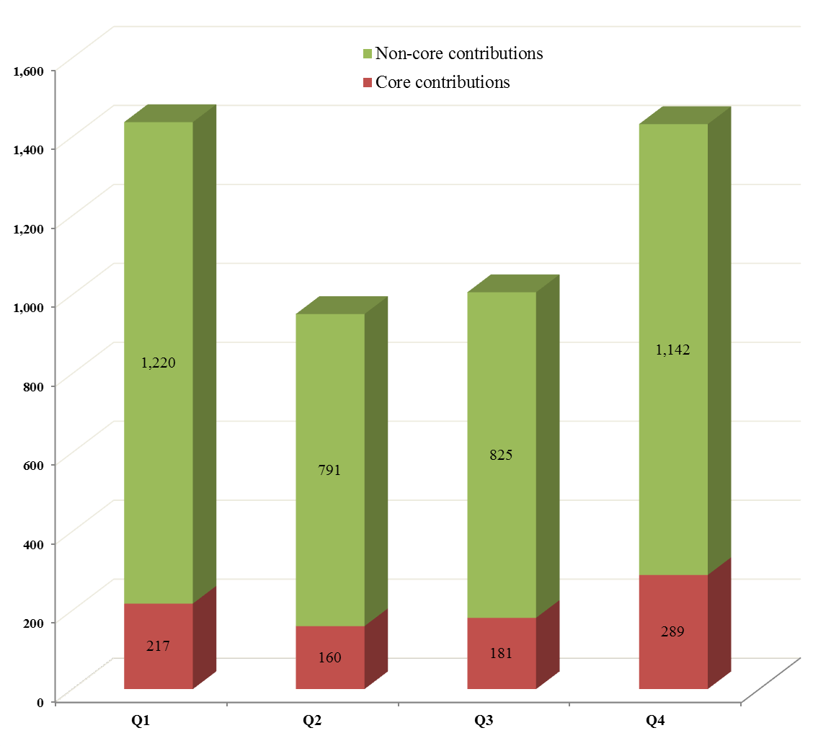
Non-core = other; core = regular

13. UNDP is committed to United Nations reform initiatives and to the optimization of its country-level coordination role in support of national development efforts. Total revenue for United Nations system coordination at the country level, and trust funds and joint programmes managed by UNDP as administrative agent, was $1.38 billion ($1.50 billion in 2011). Contributions to country-level transition funds of multi-donor trust funds, notably the Haiti Reconstruction Fund, decreased. The $1.38 billion figure includes $788 million (2011: $887 million) for multi-donor trust funds for which UNDP served as administrative agent; and $591 million (2011: $607 million) for management and operational services provided to other United Nations organizations. In addition, UNDP contributed $120 million to United Nations development coordination activities (2011: $155 million).

III. Regular resources
14. Total regular resources revenue, inclusive of voluntary contributions, investment interest revenue and other revenue, was $0.95 billion. Of this, regular resources contributions revenue amounted to $0.85 billion (2011: $0.98 billion). Total expenses in 2012 were $1.03 billion (2011: $0.98 billion). The $81 million excess of expenses over revenue was funded from the accumulated surplus.

Figure 3. Regular resources revenue and expenses, 2003-2012
(in billions of dollars)
A. Revenue

15. Total regular resources revenue was $0.95 billion, inclusive of voluntary contributions, investment revenue, and other revenue.
Voluntary contributions
16. Voluntary contributions to regular resources totalled $0.88 billion (see table 2). Of this, regular resources contributions revenue, which is recorded on a similar basis to prior years, was $0.85 billion (2011: $0.98 billion), a 13 per cent decrease. This decrease is under-representative in that additional contributions equivalent to $49 million relating to 2012 were received, and will be recorded as revenue, in 2013. The decline from 2011 to 2012 is partly due to a decrease in the local currency contributions ($105 million), and foreign exchange effects ($23 million), which were partially offset by hedging gains ($1 million).
17. As shown in table 3, contributions revenue from the top 10 donors fell to $730 million (2011: $794 million). Several bilateral donors maintained their contributions, including Belgium, Denmark, Finland, Luxemburg, New Zealand, Norway, the Republic of Korea, Sweden, Switzerland, and the United Kingdom. Several donors reduced their contributions in local currency, including 10 of the Development Assistance Committee countries of the Organisation for Economic Co-operation and Development. A total of 50 Member States contributed towards regular resources, including 23 programme countries, notably the People’s Republic of China, at $4 million; Saudi Arabia, at $2 million, and Turkey, at $1 million. Cyprus, Kazakhstan, Mozambique, and Sri Lanka all resumed making contributions in 2012.
Table 3. Regular resources contributions from top 10 donors, 2011-2012

Donor | Contributions in local currency (millions) |  |  | Contributions in  millions of dollars
Donor | 2011 | 2012 | Per- centage change | 2011 | 2012 | Per- centage change
Norway | 770 | 770 | - | 132 | 138 | 5%
Sweden | 689 | 689 | - | 105 | 103 | -2%
United Kingdom of Great Britain and Northern Ireland | 55 | 55 | - | 88 | 87 | -1%
Japan * |  |  |  | 82 | 80 | -2%
United States of America |  |  |  | 84 | 78 | -7%
Netherlands | 66 | 58 | -12% | 95 | 71 | -25%
Switzerland | 54 | 54 | - | 59 | 58 | -2%
Denmark | 320 | 320 | - | 60 | 58 | -3%
Germany | 27 | 22 | -19% | 38 | 29 | -24%
Belgium | 21 | 21 | - | 30 | 28 | -7%
Total of top 10 donors ** | N/A | N/A | N/A | N/A | 730 | N/A
Others | N/A | N/A | N/A | 202 | 116 | -43%
Core - total voluntary contributions *** |  |  |  | 975 | 846 | -13%
Source: Table 5, DP/2013/43/Add.1.
* Contributions from Japan are pledged and received in dollars.
** See paragraph 15 for 2011 top 10 donor amounts as reported in /2012/17
** A late substantial payment of $49 million for 2012 was received, and will be recorded as revenue, in 2013.
N/A = not available
Investment revenue
18. Investment revenue from regular resources totalled $13 million (2011: $18 million). The decrease was due largely to continued monetary easing policies of central banks and the resulting lower interest rate environment. As in 2011, UNDP avoided any loss of principal in its investments, despite financial market volatility.
Other revenue
19. Other revenue, mainly comprising miscellaneous revenue and exchange gains, amounted to $52 million (2011: $37 million) due in part to exchange rate fluctuations.

B. Expenses
20. In accordance with decision 2010/32, expenditures are reported in 2012 in four cost-classification areas: (a) development; (b) United Nations development coordination; (c) management; and (d) special purpose. Expenditures that do not fall under any of those cost classifications, are reported as part of overall expenditure.
21. Total regular resources expenses were $1.03 billion (2011: $0.98 billion), remaining above the level of total revenue by drawing upon the accumulated surplus. Total regular resources expenses, by cost classification, are reflected in table 4.

Table 4. Regular resources expenses, by cost classification
(in millions of dollars)
 |  | 2012
Development activities:
 | Programme | 490
 | Development effectiveness | 96
Subtotal development activities |  | 586
United Nations development coordination activities |  | 79
Management activities |  | 262
Special purpose activities |  | 18
Other |  | 86
Total expenses |  | 1,031

Development expenses
22. Development activities comprise programme and development effectiveness activities. Expenses amounted to $586 million; actual budget expenditure amounted to $595 million (2011: $564 million).
United Nations development coordination expenses
23. These are expenses support the coordination of development activities of the United Nations system. Expenses on those activities amounted to $79 million; actual budget expenditure amounted to $79 million (2011: $91 million).
Management expenses
24. Expenses amounted to $262 million in 2012; actual budget expenditure amounted to $265 million (2011: $233 million). The increase was due to shift in costs from the ‘special purpose’ to the ‘management’ category.
Special purpose expenses
25. Expenses incurred totalled $18 million; actual budget expenditure was $14 million (2011: $18.5 million). Of that $18 million, $17 million was expensed on the UNV programme and UNCDF. In 2011, special purpose activities totalled $50 million, which included costs now represented under the ‘management activities’ category.
Other expenses
26. Other expenses totalled $86 million. Of that amount, $29 million related to after-service health insurance, and $39 million from the revaluation of currencies and exchange rate fluctuations.
27. UNDP participates in the United Nations system-wide review to value post-retirement benefits. The latest valuation was carried out as at 31 December 2012. The after-service health insurance liability, valued at $979 million, is now recorded as a UNDP liability in accordance with the new accounting standards.
28. UNDP has been setting aside resources to fund it. As of 31 December 2012, $495 million was funded, and a funding strategy was formulated to fund the gap between the actuarial valuation and the amount funded over 15 years.

C. Regular resources and institutional budget expenditure
29. For activities reported in 2012, UNDP operates within the framework of two Executive Board-approved legislative instruments concerning regular resources-financed activities: (a) programming arrangements, and (b) the institutional budget. With respect to the programming arrangements, the Executive Board approved a framework outlining how available regular resources were to be allocated during the 2008-2013 period. With respect to the institutional budget, the Executive Board approved a budget representing a ceiling below which spending needs to be contained during the 2012-2013 period. In the 2012 financial statements, statement V compares the composite of the annualized institutional budget attributed to 2012 plus the internal allocation according to the Executive Board-approved programming arrangements framework with actual expenditure levels. The actual expenditure amounts are calculated on the same basis as the corresponding budget (modified accruals basis). The statement is presented as annex III.
30. The institutional budget covers the functions that support operational activities. The amounts in table 5 are calculated on the basis as the corresponding budget. Total institutional budget expenditure increased by approximately 2 per cent, from $375 million to $382 million. This was in line with the UNDP strategy to contain growth in the institutional budget.
Table 5. Institutional budget expenditure,
by cost classification
(in millions of dollars)

31. The annualized amounts for the institutional budget for 2012 were $66 million for development effectiveness activities; $72 million for United Nations development coordination activities; $265 million for management activities; and $17 million for special purpose activities.
32. Government contributions towards local office costs represent an important source of revenue. These contributions can be made as cash or as an in-kind donation. They also represent an acknowledgement by host governments of the value of the UNDP country office presence.
33. The value of in-kind contributions increased ($11.6 million) compared to 2011, ($11.4 million). Cash contributions decreased by $1.2 million (5 per cent) over 2011 levels to $21.7 million. The Administrator appreciates efforts made by many programme countries in meeting their government contributions to local office costs obligations. In cases of non-compliance, UNDP will maintain the option of withholding a portion of institutional budget resources from countries with significant deficits.

D. Accumulated surplus (formerly ‘unexpended resources’)
34. The accumulated surplus at 31 December 2012, excluding the operational reserve, was $123 million (2011: $244 million – see annex II). The regular resource accumulated surplus has resulted in (a) net adjustments under the new accounting standards of $87 million, which includes the recording of $148 million in past after-service health insurance liabilities; (b) the $80 million surplus of expenses over revenue in 2012; and (c) a $97 million increase in the value of the after-service health insurance liability due to external economic conditions and actuarial assumptions in 2012. The accumulated surplus includes $13 million that was transferred back from the regular resources operational reserve.
35. Significant funds were received in the last quarter of 2012 ($289 million, or 34 per cent of contributions), distorting the accumulated surplus reported at year-end. In addition, specific cash balances were set aside for regulatory reasons, such as for the operational reserve.
36. A prudent level of liquidity for UNDP regular resources would be the equivalent of expenditures for three to six months, implying a total liquidity of between $230 million and $460 million at the 2012 expenditure level. Despite the challenging environment and late receipt of contributions, at the end of 2012 UNDP maintained the year-end liquidity position at approximately 3.71 months of working capital, within the minimum threshold of liquidity.
37. In 2012, based on the formula for the statutory reserve requirements approved by the Executive Board in decision 1999/9, and on the final income and expenditure figure for 2012, the regular resources operational reserve was adjusted downwards, and $13 million was transferred back to the regular resources fund balance.
38. Based on the final income and expenditure data for 2012, the operational reserve will be adjusted downwards, from $213 million to $202 million. The remaining $11 million will be transferred to the general resources of UNDP in 2013.

IV. Other resources
39. Other resources are composed of three funding sources: cost sharing; trust funds; reimbursable support services and miscellaneous activities. Reimbursable support services include the Junior Professional Officers programme, the UNV programme, and management service agreements.

A. Revenue
Voluntary contributions
40. The $3.86 billion voluntary contributions consist of: (a) contributions revenue of $3.98 billion, comprising $3.90 billion contributions received and $0.08 billion of contributions receivable; and (b) refunds, in-kind contributions and transfers of $0.12 billion, which reduced contributions revenue.
41. As shown in figure 4, voluntary contributions of $3.86 billion are composed of $2.86 billion for cost sharing (2011: $2.84 billion); $0.81 billion for trust funds (2011: $0.9 billion); and $0.19 billion for reimbursable support services and miscellaneous activities (2011: $0.23 billion).

Figure 4. Other resources voluntary contributions,
by funding source, 2012
(in millions of dollars)
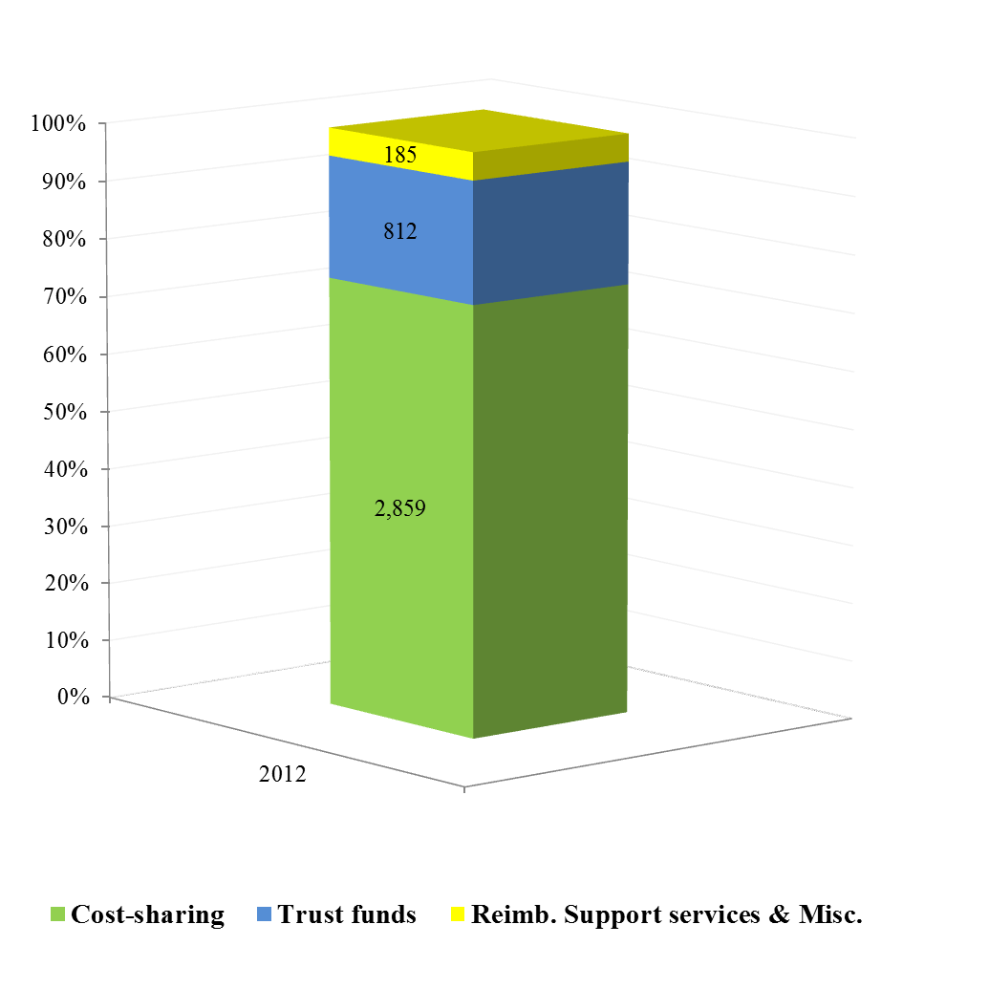

42. Other resources contributions revenues in 2012, by funding source, are set out in table 6.

Table 6. Contributions revenue by funding source, 2012
(in billions of dollars)
Funding source | Donor resources |  |  | Local resources |  |  | Other | Total resources
Funding source | Bilateral resources | Multilateral resources | Total donor resources | Programme country governments | Local partners | Total local resources | Other | Total resources
2012 | 1.41 | 1.55 | 2.96 | 0.85 | 0.08 | 0.93 | 0.09 | 3.98

Bilateral resources
43. Other resources contributions revenue from bilateral donors totalled $1.41 billion (2011: $1.59 billion), including contributions receivable of $33 million. Figure 5, represents the top 10 bilateral donors and their contributions revenue to other resources, which amounted to $1.22 billion (87 per cent of total voluntary contributions revenue from bilateral donor governments).
Figure 5. Other resources contributions revenue,
top 10 bilateral donors, 2012
(in millions of dollars)
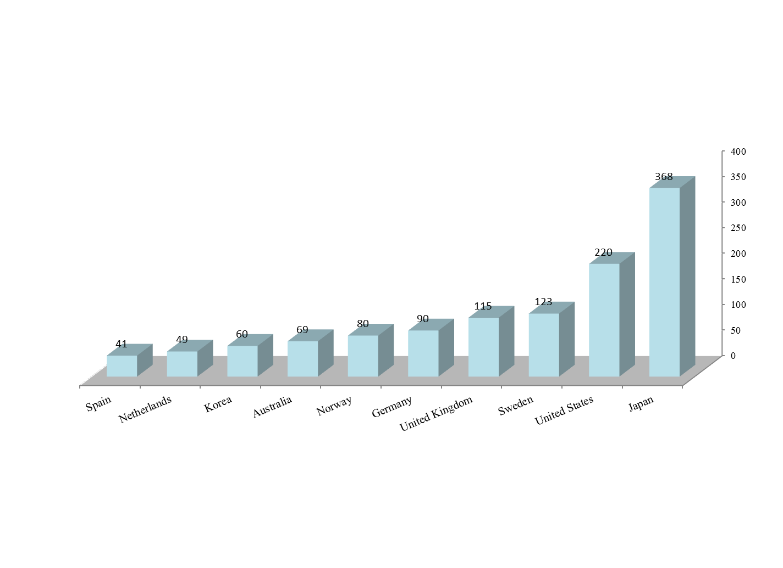
Multilateral resources
44. Contributions revenue from multilateral partners amounted to $1.55 billion (2011: $1.54 billion), inclusive of $50 million in contributions receivable. Figure 6, represents the breakdown of multilateral partners that contributed to other resources. Revenue from contributions to the Global Fund to fight Aids, Tuberculosis and Malaria in 2012 was $527 million (2011: $351 million). Within the ‘private sector’ category, foundations and non-governmental organizations, the Gates Foundation and the IKEA Foundation were the top contributors, with contributions of $10 million and $8 million, respectively.

Figure 6. Other resources contributions revenue –
multilateral resources, 2012
(in millions of dollars)
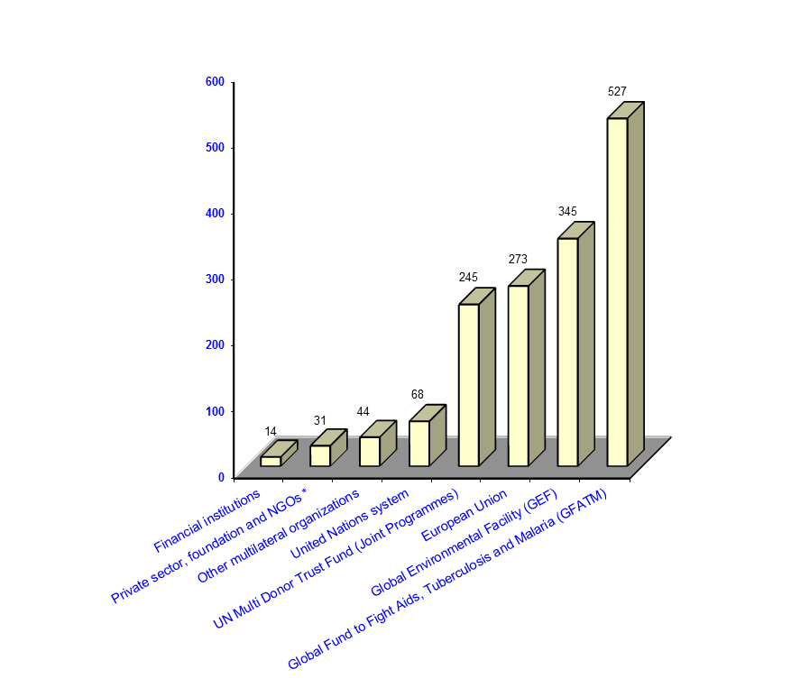*Non-governmental organizations

Local resources – Programme country governments and local partners
45. Local resources are defined as contributions revenue – excluding management service agreements – channeled through UNDP by programme country governments and other local partners. Such contributions increased to $0.93 billion in 2012 (2011: $0.89 billion), representing 23 per cent of total other resources contributions revenue (2011: 22 per cent).
46. Of that $0.93 billion, programme country government contributions accounted for $0.85 billion (2011: $0.86 billion), with 76 per cent from the governments of 10 programme countries (see figure 7). Among the top 10 countries, Argentina, Colombia, El Salvador, Mexico, Paraguay, Peru, Saudi Arabia, and Venezuela increased their contributions significantly; Kuwait and Panama also increased their contributions.
47. Contributions revenue from local partners totalled $0.08 billion (2011: $0.03 billion). Private national organizations in Brazil contributed $48 million for the United Nations Conference on Sustainable Development, ‘Rio+20’, which took place in June 2012. This represented 65 per cent of 2012 contributions from local partners.
Figure 7. Programme country governments – contributions revenue, top 10 countries, 2012
(in millions of dollars)
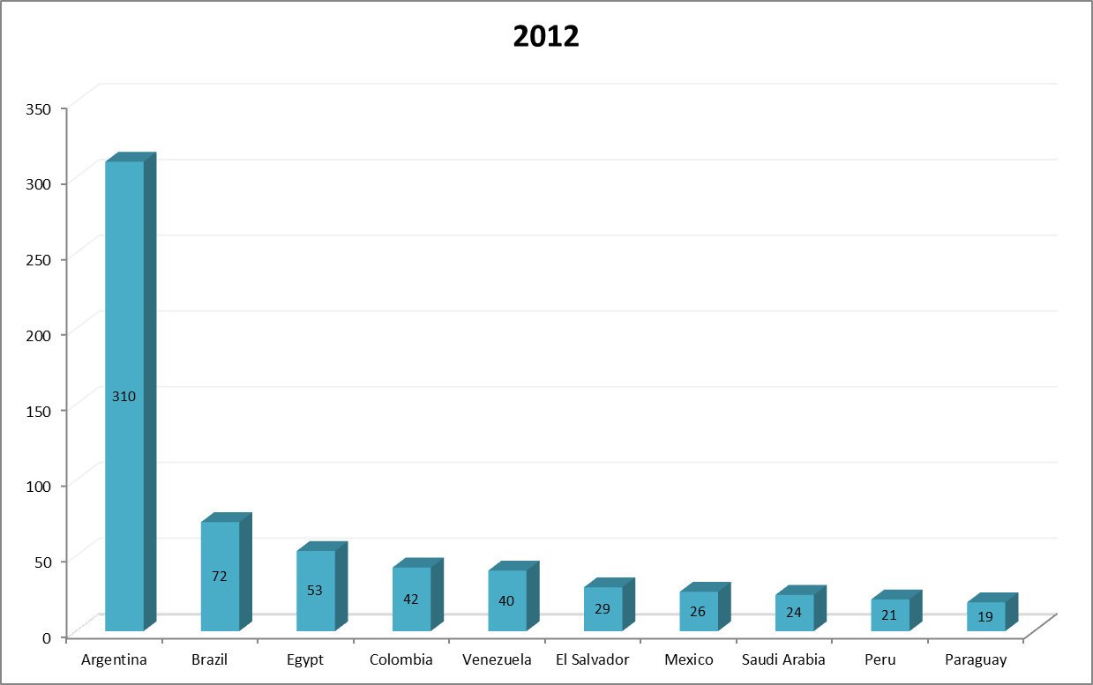

48. Management service agreements total revenue in 2012 totalled $47 million, consisting of $45 million net in voluntary contributions and $2 million in investment revenue. The $45 million results from $74 million contributions revenue recognized in 2012 (2011: $96 million); donor approved transfers amounting to total $5 million; and a total of $34 million refunded to donors, due primarily to the early conclusion of activities in a single country. The distribution of revenue is shown in DP/2013/43/Add.1.
Investment revenue
49. Investment revenue of other resources was $52 million in 2012 (2011: $63 million). The decrease was attributable to lower yields in financial markets.
Miscellaneous revenue
50. Miscellaneous revenue consisted of revenue from the provision of services (exchange transactions), $198 million, and other miscellaneous revenue of $246 million. Other revenue consisted largely of $219 million in cost recovery fees; reimbursements for common services and miscellaneous, $26 million; and $1 million in foreign exchange gains.

B. Expenses
51. Overall expenses of other resources amounted to $4.44 billion (2011: $4.74 billion), remaining above the level of total revenue by drawing upon the accumulated surplus. Table 7 reflects the expenses in cost classification categories.

Table 7. Other resources expenses,
by cost classification category, 2012
(in millions of dollars)

 |  | 2012
Development activities:
 | Programme | 3,903
 | Development effectiveness | 51
Subtotal development activities |  | 3,954
United Nations development coordination activities |  | 42
Management activities |  | 221
Special purpose activities |  | 26
Other |  | 202
Total expenses |  | 4,445

52. The overall expenses of $4.45 billion, by funding source, are shown in figure 8.

Figure 8. Other resources: overall expenses, /
by funding source, 2012
(in millions of dollars)

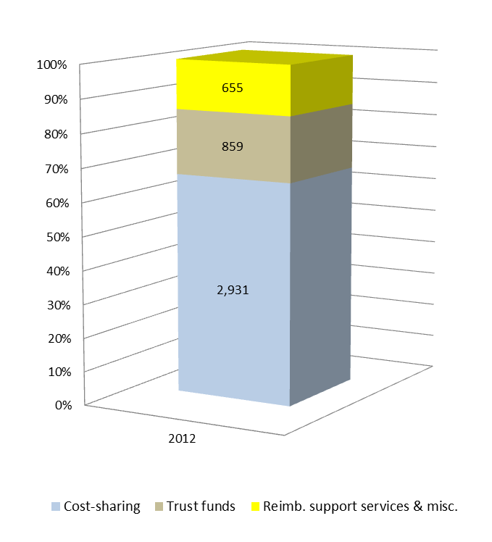
53. The breakdown of cost-sharing expenses, by funding source, is shown in figure 9, below. Of $2.93 billion, 32 per cent was funded by bilateral resources, 39 per cent by multilateral resources, 27 per cent by programme country governments, and 2 per cent by local partners.

Figure 9. Breakdown of cost-sharing expenses, 2012
(in millions of dollars)
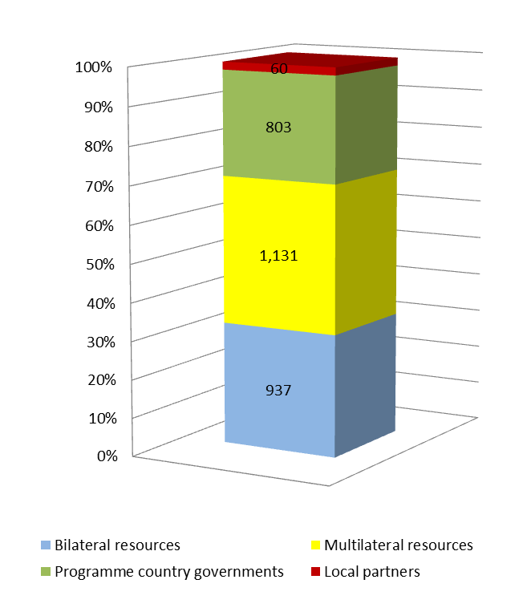
Development expenses
54. Expenses for development activities comprised $3.90 billion for programme and $0.05 billion for development effectiveness activities expenses. Cost-sharing development expenses in 2012 amounted to $2.93 billion (2011: $2.98 billion); trust funds development expenses totalled $0.83 billion (2011: $0.98 billion); and reimbursable support services and miscellaneous activities development expenses amounted to $0.19 billion (2011: $0.30 billion).
United Nations development coordination
55. A total of $42 million was spent on development coordination activities in the ‘other resources’ category (2011: $63 million), reflecting $16 million received from funds for country coordination and for support to the resident coordinator function. As a result of the biennial workload study, a further $25 million was attributed to country office costs.
Management expenses
56. Total expenses amounted to $221 million (2011: $158 million).
Special purpose expenses
57. Special purpose expenses totalled $26 million (2011: $47 million), reimbursable support service activities.
Other expenses
58. Other expenses (as defined in the cost classification) totalled $202 million (2011: $221 million). Of this, $90 million was related to staff security (funded by the United Nations Department of Safety and Security), $22 million to the UNDP share of common service activities; and $24 million to after-service health insurance.

C. Cost recovery policy
59. In line with decisions 2006/30 and 2007/18, whereby the Executive Board stipulated that regular and other resources should fund and support the priorities set out in the strategic plan and that regular resources should not subsidize the cost of programmes funded by other resources, the UNDP cost recovery policy establishes that all costs associated with the delivery of other resources-funded programmes at the country and headquarters levels are to be fully covered through specific cost-recovery mechanisms. That important principle was reaffirmed by the Executive Board in its decision 2013/9.
60. UNDP makes every effort to recover the general management and implementation costs associated with the delivery of other resources-funded programmes and projects at the country and headquarters levels, and with other United Nations entities. The objective is to ensure that the UNDP institutional budget does not bear costs that it was never intended to bear.
61. Cost recovery income and its utilization in 2012 are shown in table 8, below. Adoption of the new accounting standards changed the reporting of common services in the 2012 financial statements so that these amounts were no longer included in revenue, but were reported as ‘due to/due from’ within the statement of financial position. Common services funds have therefore been excluded from the ‘reimbursable support services’ category.

Table 8. Cost recovery, 2012
(in millions of dollars)
Cost recovery | Programme and project delivery | Reimbursable support services | Total
Income
General management/implementation support services | 221 |  | 221
United Nations organizations reimbursable services | 25 | 39 | 64
Interest | 6 |  | 6
Administrative agent fees | 1 |  | 1
Other | 23 |  | 23
Total income | 276 | 39 | 315
Expenditure
Total expenditure | 263 | 31 | 294

62. Total cost recovery income in 2012 totalled $315 million, and total expenditure amounted to $294 million. Included in the cost recovery income of $276 million listed in table 3, above, is $221 million in general management support income from cost sharing and trust funds. To avoid duplication, that income is not included in the ‘total other income’ of other resources. In the 2012-2013 institutional budget document (DP/2011/34), UNDP reported on the exceptions granted on the cost recovery policy. In 2012 three additional general management support waivers were granted: (a) a reduced (4.57 per cent) fee for a contribution to ‘Building Transformative Policy and Financing Frameworks to Increase Investment in Biodiversity Management’, Bureau for Development Policy; (b) a reduced (3 per cent) fee for a contribution to the Deprived Families Economic Empowerment Programme, Programme of Assistance to the Palestinian People; and (c) a reduced (5 per cent fee) for a contribution to the Poverty Sustainable Development, Millennium Development Goals project in Colombia.

D. Accumulated surplus (formerly ‘unexpended resources’)
63. The accumulated surplus balance at the end of 2012 continued to fall, to $4.18 billion (2011: $4.24 billion – see annex II). The amount represented 97 per cent of the UNDP overall accumulated surplus. The balance of $4.18 billion consisted of $2.56 billion (2011: $2.39 billion) from cost sharing, $1.10 billion from trust funds (2011: $1.05 billion), and $0.52 billion (2011: $0.86 billion) from reimbursable support services. The vast majority of these funds have been programmed for delivery in future years.
64. Noting that UNDP partners provide funding in advance, the accumulated surpluses of $4.18 billion were used to absorb the current-year deficit. Significant funds (29 per cent of other resources contributions) were received in the last quarter of 2012, a pattern which distorts the accumulated surplus reported and influences the peak levels of cash at year-end.
65. UNDP is required by its financial regulations and rules to operate on a fully-funded basis for all other resources activities. In accordance with current partnership agreements, all project balances are completely segregated for accounting and reporting purposes. The cash is held for discrete purposes, with no commingling or ‘sharing’ of balances between projects and no fungibility of resources for commitment or disbursement of funds. In addition, specific cash balances set aside for regulatory reasons – such as the operational reserve – are earmarked future liabilities (such as after-service health insurance) or are held to meet the requirements of routine operations, such as settling current liabilities.
66. Over the past four years, UNDP has continued to draw down its accumulated surplus. UNDP maintains that the current level of accumulated surplus is reasonable, taking into account the timing of the receipt of funds, the programme cycle, and the UNDP governance framework as approved by the Executive Board and documented in the financial regulations and rules.

E. Others

United Nations Volunteers programme
67. In 2012, 6,807 United Nations Volunteers from 127 nations, supported 27 United Nations entities in their work towards peace and development in 159 countries. The total financial value of UNV programme operations amounted to $220 million in 2012 (2011: $236 million), which included and was supported by UNDP regular resources expenditure. Of this, programme resource expenditure made directly by the UNV programme – through the special voluntary fund, cost sharing, trust funds and full funding arrangements – amounted to $20 million (9 per cent). The remaining financial value is attributable to direct charges to United Nations programmes. The special voluntary fund provides resources for cultivating diversified approaches that widen volunteer opportunities and deepen the programmatic integration of volunteerism. In 2012, this included seed funding for a United Nations youth volunteer programme and related trust fund to promote youth volunteerism and voices in line with the Five-Year Action Agenda of the Secretary-General (2012-2017).
Junior Professional Officers programme
68. A total of 26 governments have agreements with UNDP for the provision of junior professional officers, while four have valid agreements with UNDP for the provision of special assistants to resident coordinators. At 31 December 2012, UNDP administered 259 junior professional officers and 32 special assistants. Of this number 156 were working with UNDP and affiliated funds and programmes as of 31 December 2012.
69. In 2012, UNDP recognized $24 million in revenue for the Junior Professional Officers programme; total expenses, including support costs, amounted to $23 million. The accumulated surplus available at the end of 2012 was $23 million (2011: $34 million). UNDP received $22 million from other United Nations organizations and partners to administer 135 junior professional officers on their behalf, and a total of $21 million was delivered in 2012.
Direct budget support
70. In its decision 2008/24, the Executive Board endorsed a four-year pilot (commencing September 2008) allowing UNDP financial contributions to pooled funding and sector budget support, on a case-by-case basis upon the request of the recipient country, in accordance with the mandate of UNDP and in line with the guidance provided in DP/2008/36 and its corrigenda 1 and 2. In its decision 2013/3, the Executive Board reviewed the engagement of UNDP in direct budget support and pooled funding and agreed to a subsequent pilot period, 2013-2014.
71. A request from the Government of Burkina Faso for UNDP participation in sector budget support was approved in 2009 for two projects HIV/AIDS and human rights promotion. Each initiative falls within the core mandate of UNDP. The UNDP contribution to sector budget support in Burkina Faso for 2012 in the areas of HIV/AIDS amounted to $100,000 out of a total contribution of $10,199,119. This represented 0.98 per cent of HIV/AIDS sector budget funds. Additionally, a request from the Government of Burkina Faso was approved on 28th September 2012 for access to energy services in rural areas. Overall, total UNDP contributions to basket funds funded from regular resources is below the cap of 10 per cent of the annual authorized spending limit of regular resources funds contained in the resource planning framework established by the Executive Board.

V. United Nations reform and support to other United Nations organizations
72. UNDP coordinates the United Nations system at the country level and plays a vital role in fostering development coherence. Based on the available data, the value of joint programmes, fund flows to multi-donor trust funds, and support to other United Nations organizations totalled $1.38 billion (2011: $1.50 billion).

A. UNDP administrative agent function
73. UNDP supports joint programming activities both through its role as administrative agent of joint programmes and multi-donor trust funds on behalf of the United Nations development system and through its programme implementation role as a participating United Nations organization. The total value of contributions received by UNDP for multi-donor trust funds was $788 million (2011: $887 million), including $4 million for national funds such as the Ecuador Yasuni Capital Window. The decrease in overall contributions can be largely attributed to the decrease in country-level transition funds, notably the Haiti Reconstruction Fund. The total value of funds transferred by the Multi-Partner Trust Fund Office, in its role as administrative agent for all participating organizations, was $827 million (2011: $1.02 billion), drawing upon a portion of the 2012 accumulated surplus of $589 million. This includes $279 million transferred to UNDP for UNDP programmes (2011: $363 million).

B. Support to United Nations organizations
74. UNDP country offices provide support to other United Nations organizations. The funds for those services, recorded in United Nations organization services clearing accounts, totalled $591 million (2011: $607 million).

C. United Nations development coordination activities
75. UNDP plays significant roles in United Nations system coordination and in country-level coordination in support of national development. .Combined expenses totalled $120 million ($79 million from regular resources and $41 million from other resources).
D. United Nations-mandated security costs
76. In its decision 2011/32, the Executive Board approved the net amount of $33 million as a separate requirement from regular resources for United Nations-mandated security costs for the 2012-2013 biennium. The Administrator was granted the exceptional authority, during 2012-2013, to disburse, if needed, up to an additional 46 per cent ($15 million) of the $33 million for new and emerging security mandates as defined in United Nations Department of Safety and Security directives. No disbursements were made against the exceptional authority granted.
77. The $33 million approved by the Executive Board forms part of a total estimated requirement of $75 million in 2012-2013 for security measures .That sum consisted of $33 million from regular resources and $42 million from other resources. In 2012, UNDP spent $31 million (2011: $31 million), including $17 million (2011: $15 million) in other resources. Of the $31 million expensed, $19 million (2011: $20 million) was associated with the UNDP share of the United Nations field security coordination programme, and $12 million (2011: $11 million) with country office security assessments security compliance, improvement of premises security, blast and seismic assessments, and office relocations, both in the field and at headquarters locations.

VI. International Public Sector Accounting Standards
78. The International Public Sector Accounting Standards were adopted on 1 January 2012, in accordance with General Assembly resolution 60/283.
79. Their implementation was an entity-wide effort. For the first time, UNDP financial statements were prepared in accordance with the standards. The new standards improved the transparency of information provided in UNDP financial statements. As of 2012, employee costs and associated obligations such as annual leave and after-service health insurance have been recognized and allocated to the funding sources of the activities from which they arise. The standards do raise the complexity of UNDP financial activities. While that risk is being mitigated by the Global Shared Service Centre, other risks emerge due to the decentralized nature of UNDP.
80. The Executive Board, in its decision 2011/1, approved a total of $13 million for International Public Sector Accounting Standards-related activities during 2011-2013. This included funding for policy formulation; systems configuration; report development; global training; and Global Shared Service Centre costs. In 2012 UNDP spent $5 million (2011: $7 million) for adoption of the standards and $450 thousand on Global Shared Service Centre costs. Additional expenses will be incurred in 2013 for remedial training, additional reporting and process improvement. As the standards evolve, further investments will be required to ensure the adoption of future standards mandated by the International Public Sector Accounting Standards board.

VII. ‘Greening’ UNDP
81. In 2012 UNDP continued to demonstrate leadership by example in the fight against climate change and in its work to minimize the environmental impact of its operations. UNDP reported its fourth global annual greenhouse gas inventory including data from over 60 UNDP offices, and continued to track and disclose its environmental performance consistent with its overall accountability standards. UNDP offices were working on establishing and implementing meaningful and credible ‘green action’ plans. Increasingly, UNDP offices engage in carbon emissions offsetting activities: In 2012 headquarters joined the Bratislava Regional Centre in becoming the second climate-neutral UNDP office by reducing greenhouse gas emissions (including through a switch to renewable electricity – ‘renewable energy certificates’) and offsetting remaining emissions with high-quality certified emission reductions from projects contributing to sustainable development priorities and the Millennium Development Goals.
82. Headquarters efforts towards climate neutrality are supported by a 2 per cent travel supplement charged on all headquarters-booked travel to purchase ‘renewable energy credits’ and ‘certified emission reductions’. For 2012, the purchase of energy credits totalled $3,900 and purchase of emission reductions totalled $41,400. Remaining supplement funds will be used to build an infrastructure to support ‘greening’ initiatives in all UNDP offices, including the development of guidance and toolkits, review of operational frameworks, and training.

VIII. Funds administered by UNDP

United Nations Capital Development Fund

83. Detailed data for UNCDF (which is administered by UNDP), are provided in table 10 of the addendum to the present report (DP/2013/43/Add.1).
84. In 2012, UNCDF operated in 37 of the 49 least developed countries, offering concrete approaches to poverty eradication through the promotion of inclusive, sustainable growth.
85. Total net voluntary contributions of $54 million consisted of contributions revenue of $55 million and a refund to donors of $0.7 million. UNCDF contributions revenue grew to a record level of $55 million in 2012 (2011: $50 million). The UNCDF donor base continued to diversify, with 36 donors (up from 33 in 2011 and 20 in 2007), six of which were major private sector foundations that contributed $10 million to UNCDF (17 per cent of total revenue). Although the record revenue is a sign of strong demand for UNCDF services, it was due entirely to growth in other resources. In 2012 contributions to UNCDF regular resources decreased by 11 per cent, to $14.5 million, due to fiscal constraints of donor governments and exchange rate fluctuations. Regular resources contributions remained well short of the $25 million per year required as a minimum to sustain UNCDF operations in 37 of the 49 least developed countries, as envisaged in the UNCDF investment plan. Among the top five donors to UNCDF in 2012, the largest was Sweden, which contributed $11 million, followed by Norway, the MasterCard Foundation, Belgium, Luxembourg and the European Commission.
86. Total expenses for development activities in 2012 totalled $48 million, including programme expenses of $45 million and development effectiveness expenses of $3 million (other resources development expenses accounted for 56 per cent of total development expenses). All programme expenditures were for joint programmes with UNDP. UNCDF disbursed $17 million in grants, as reflected in expenses. The total operational reserve for both UNCDF regular and other resources was $25 million. Accordingly, UNCDF was able to deliver its planned development, management and financial results while sustaining its liquidity.
87. The $48 million in development expenses excludes $1 million allocated to UNCDF by UNDP in accordance with decision 2007/34. That amount was fully expended by UNCDF but is separately recorded and reported by UNDP. In addition, $4 million in the UNDP institutional budget was set aside for UNCDF management expenditures.

Annex I.
UNDP overview

- Statement of financial performance for the year ended 31 December 2012^{a/}

(in thousands of dollars) |  | Regular resources | Cost sharing | Trust funds | Reimbursable support services and misc. activities | Elimination^{c/} | Total UNDP
Revenue
 | Voluntary contributions, net | 884,357 | 2,859,471 | 812,003 | 185,348 | - | 4,741,179
 | Revenue from exchange transactions | 58 | 320 | 5 | 197,317 | - | 197,700
 | Investment revenue | 13,188 | 29,187 | 13,352 | 9,611 | - | 65,338
 | Other revenue | 52,445 | 5,362 | 1,814 | 238,879 | - | 298,500
Total revenue before elimination |  | 950,048 | 2,894,340 | 827,174 | 631,155 | - | 5,302,717
 | Elimination - internal UNDP cost recovery |  |  |  |  | (213,364) | (213,364)
Total revenue |  | 950,048 | 2,894,340 | 827,174 | 631,155 | (213,364) | 5,089,353
Expenses ^{b/}
 | Development activities
 | Programme | 490,450 | 2,931,410 | 823,124 | 148,379 | - | 4,393,363
 | Development effectiveness | 96,161 |  | 3,532 | 47,279 | - | 146,972
 | Subtotal - development activities | 586,611 | 2,931,410 | 826,656 | 195,658 | - | 4,540,335
 | UN development coordination activities | 78,641 | - | - | 41,740 | - | 120,381
 | Management activities | 262,328 | - | 31,838 | 189,827 | - | 483,993
 | Special purpose activities | 18,004 | - | - | 25,822 | - | 43,826
 | Other activities | 85,679 | - | - | 201,935 | - | 287,614
Total expenses before elimination |  | 1,031,263 | 2,931,410 | 858,494 | 654,982 | - | 5,476,149
 | Elimination - internal UNDP cost recovery |  |  |  |  | (213,364) | (213,364)
Total expenses |  | 1,031,263 | 2,931,410 | 858,494 | 654,982 | (213,364) | 5,262,785
Deficit for the period |  | (81,215) | (37,070) | (31,320) | (23,827) | - | (173,432)

Source: Table 2a, DP/2013/43/Add.1.
^{a/}Comparative amounts are not shown in the table as 2012 amounts (International Public Sector Accounting Standards) are not directly comparable to 2011 (United Nations system
accounting standards) amounts
^{b/}Includes general management support service cost.
^{c/}This adjustment is required to remove the effect of internal UNDP cost recovery.

- Statement of financial position as at 31 December 2012

(in thousands of dollars) |  | Regular resources | Cost sharing | Trust funds | Reimbursable support services and misc. activities | Total UNDP
ASSETS
Current assets
 | Cash and cash equivalents | 119,473 | 393,157 | 168,989 | 184,491 | 866,110
 | Cash and cash equivalents – funds held-in-trust | 266,613 | - | - | - | 266,613
 | Investments | 244,063 | 803,688 | 346,821 | 377,147 | 1,771,719
 | Investments – funds held-in-trust | 215,386 | - | - | - | 215,386
 | Receivables – non-exchange transactions | 2 | 56,032 | 33,045 | 5,344 | 94,423
 | Receivables – exchange transactions, net | 493,618 | 504 | 259 | 6,188 | 500,569
 | Advances issued, net | 30,755 | 223,560 | 117,306 | 1,397 | 373,018
 | Inventories | 2,022 | 20,312 | 475 | 1,132 | 23,941
 | Other current assets, net | 806 | 345 | 76 | 3 | 1,230
Total current assets |  | 1,372,738 | 1,497,598 | 666,971 | 575,702 | 4,113,009
Non-current assets
 | Investments | 325,266 | 1,084,877 | 472,352 | 509,101 | 2,391,596
 | Investments – funds held-in-trust | 30,676 | - | - | - | 30,676
 | Loans to governments | - | - | - | 13,458 | 13,458
 | Property, plant and equipment | 37,637 | 9,508 | 2,342 | 43,423 | 92,910
 | Intangible assets | 2,911 | - | 134 | 2,789 | 5,834
Total non-current assets |  | 396,490 | 1,094,385 | 474,828 | 568,771 | 2,534,474
Total assets |  | 1,769,228 | 2,591,983 | 1,141,799 | 1,144,473 | 6,647,483
LIABILITIES
Current liabilities
 | Accounts payable and accrued liabilities | 40,665 | 26,846 | 11,396 | 26,324 | 105,231
 | Advances payable | 1,972 | 8,194 | 7,658 | 391 | 18,215
 | Funds held on behalf of donors | 22,039 | 775 | 13,495 | - | 36,309
 | Payables – funds held-in-trust | 543,421 | - | - | - | 543,421
 | Employee benefits | 135,355 | 46 | 81 | 43,616 | 179,098
 | Other current liabilities | 13,581 | 29 | 612 | 5,049 | 19,271
Total current liabilities |  | 757,033 | 35,890 | 33,242 | 75,380 | 901,545
Non-current liabilities
 | Payables – funds held-in-trust | 30,676 | - | - | - | 30,676
 | Employee benefits | 644,371 | - | - | 403,177 | 1,047,548
 | Other non-current liabilities | 6 | - | - | 4,464 | 4,470
Total non-current liabilities |  | 675,053 | - | - | 407,641 | 1,082,694
Total liabilities |  | 1,432,086 | 35,890 | 33,242 | 483,021 | 1,984,239
NET ASSETS/EQUITY
Reserves |  | 213,669 | - | 3,000 | 143,969 | 360,638
Accumulated surplus |  | 123,473 | 2,556,093 | 1,105,557 | 517,483 | 4,302,606
Total net assets/equity |  | 337,142 | 2,556,093 | 1,108,557 | 661,452 | 4,663,244
Total liabilities and net assets/equity |  | 1,769,228 | 2,591,983 | 1,141,799 | 1,144,473 | 6,647,483

Annex II.
Schedule of International Public Service Sector Accounting Standards adjustments
to 2011 accumulated surplus (formerly ‘unexpended resources’)

(in thousands of dollars) | Regular resources | Cost sharing | Trust funds | Reimbursable support services and misc. activities | Total UNDP
NET ASSETS
Accumulated surplus - 31 December 2011 (UNSAS) | 333,197 | 2,390,355 | 1,051,659 | 857,491 | 4,632,702
IPSAS adjustment for property, plant and equipment | 37,046 | 1,357 | 502 | 39,591 | 78,496
IPSAS adjustment for employee benefits | (154,938) | (1,968) | (1,049) | (378,313) | (536,268)
IPSAS adjustment for Investments | 5,955 |  | 6 |  | 5,961
IPSAS adjustment for revenue |  | 86,577 | 55,065 | (11,114) | 130,528
IPSAS adjustments - other | 24,947 | 116,841 | 30,692 | 10,775 | 183,255
Other adjustments - special capital resources |  |  |  | (8,788) | (8,788)
Prior period adjustments | (2,132) |  |  | (335) | (2,467)
Total adjustments | (89,122) | 202,807 | 85,216 | (348,184) | (149,283)
Adjusted accumulated surplus, 1 January 2012 (IPSAS) | 244,075 | 2,593,162 | 1,136,875 | 509,307 | 4,483,419

UNSAS = United Nations system accounting standards; IPSAS = International Public Service Sector Accounting Standards

Annex III. United Nations Capital Development Fund - overview

A. Statement of financial performance for the year ended 31 December 2012 ^{a/}

(in thousands of dollars) |  | Regular resources | Cost sharing | Trust funds | Reimbursable support services & misc. activities | Elimination ^{c/} | Total UNCDF
Revenue
 | Voluntary contributions, net | 14,520 | 27,363 | 11,574 | 682 |  | 54,139
 | Investment revenue | 206 | 110 | 51 | - |  | 367
 | Other revenue | 546 | 13 | 5 | 2,378 | (2,304) | 638
Total revenue |  | 15,272 | 27,486 | 11,630 | 3,060 | (2,304) | 55,144
Expenses ^{b/}
 | Development activities
 | Programme | 17,842 | 16,575 | 9,584 | 819 | (2,304) | 42,516
 | Development effectiveness | 3,551 | - | - | - |  | 3,551
 | Subtotal development activities | 21,393 | 16,575 | 9,584 | 819 | (2,304) | 46,067
 | Management activities | 2,539 | - | - | 1,987 |  | 4,526
Total expenses |  | 23,932 | 16,575 | 9,584 | 2,806 | (2,304) | 50,593
Deficit for the period |  | (8,660) | 10,911 | 2,046 | 254 | - | 4,551

^{a/}Comparative amounts are not shown in the table as 2012 amounts (International Public Sector Accounting Standards) are not directly comparable to 2011 – United Nations system
accounting standards – amounts
^{b/}Includes general management support service cost.
^{c/}This adjustment is required to remove the effect of internal UNDP cost recovery.

B. Statement of financial position as at 31 December 2012

(in thousands of dollars) |  | Regular resources | Cost sharing | Trust funds | Reimbursable support services and misc. activities | Total UNCDF
ASSETS
Current assets
 | Cash and cash equivalents | 13,218 | 15,678 | 5,437 | 2,826 | 37,159
 | Investments | 14,266 | 16,052 | 5,567 | 2,892 | 38,777
 | Receivables – exchange transactions | 278 | - | - | 1 | 279
 | Advances issued | 1,616 | 41 | 306 | 3 | 1,966
 | Other current assets | 87 | 88 | 3 | - | 178
Total current assets |  | 29,465 | 31,859 | 11,313 | 5,722 | 78,359
Non-current assets
 | Investments | 4,815 | 5,600 | 1,942 | 1,009 | 13,366
 | Loans to financial service providers | 2,910 | 297 | - | - | 3,207
 | Property, plant and equipment | 357 | 60 | 1 | 70 | 488
Total non-current assets |  | 8,082 | 5,957 | 1,943 | 1,079 | 17,061
Total assets |  | 37,547 | 37,816 | 13,256 | 6,801 | 95,420
LIABILITIES
Current liabilities
 | Accounts payable and accrued liabilities | 7,724 | 244 | 225 | 30 | 8,223
 | Employee benefits | 1,452 | 285 | 154 | 142 | 2,033
 | Other current liabilities | 38 | - | - | - | 38
Total current liabilities |  | 9,214 | 529 | 379 | 172 | 10,294
Non-current liabilities
 | Employee benefits | 11,802 | 1,605 | 807 | 1,088 | 15,302
Total non-current liabilities |  | 11,802 | 1,605 | 807 | 1,088 | 15,302
Total liabilities |  | 21,016 | 2,134 | 1,186 | 1,260 | 25,596
NET ASSETS/EQUITY
Reserves |  | 22,600 | - | - | 2,000 | 24,600
Accumulated surplus |  | (6,069) | 35,682 | 12,070 | 3,541 | 45,224
Total net assets/equity |  | 16,531 | 35,682 | 12,070 | 5,541 | 69,824
Total liabilities and net assets/equity |  | 37,547 | 37,816 | 13,256 | 6,801 | 95,420

C. Schedule V: Budget to actual comparison from 2012 financial statements

United Nations Development Programme
Original
Final
Actual
expenditure on
comparable basis
(Note 7)
Difference: final
approved budget
and actual
expenditure
(Note 7)
Development activities
Programme
534,571

534,571

498,547

36,024

Development effectiveness
96,760

96,760

96,674

86

Total
631,331

631,331

595,221

36,110

United Nations development
coordination activities
84,670

84,670

79,052

5,618

Management activities
Recurring
259,651

259,651

232,196

27,455

Non-recurring
4,900

4,900

4,322

578

Total
264,551

264,551

236,518

28,033

Special purpose activities
Non-UNDP operations
administered
by UNDP
17,444

17,444

14,255

3,189

Total
17,444

17,444

14,255

3,189

Grand total
997,996

997,996

925,046

72,950

STATEMENT V - COMPARISON OF BUDGET TO ACTUAL (REGULAR RESOURCES)
For the period ended 31 December 2012
(in thousands of dollars)
Approved Budget
____________

UNDP adopted International Public Sector Accounting Standards pursuant to General Assembly resolution 60/283, migrating from the previous United Nations system accounting standards basis. Definitions of terms are shown in annex 1.

