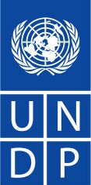

UNDP management commentaries
on the annual report on evaluation, 2013

Executive Board of UNDP, UNFPA and UNOPS
Annual session of 2014, Geneva

Contents
Background 3
I. UNDP comments on IEO activities in 2013 3
II. Strengthening results-based management and promoting a culture of evaluation in UNDP 3
A. 2013: a year of transition towards greater coherence across the organization 3
B. Strengthening monitoring and evaluation across the organization 5
C. National monitoring and evaluation capacities 7
II. Decentralized evaluation quality and compliance 7
A. Country office and bureau evaluation capacities 7
B. Evaluation plan compliance 7
C. Management responses 7
D. Quality assessment of UNDP decentralized evaluations 9
E. Coverage and use of evaluation 9
F. Challenges to evaluation quality 10
G. Quality of Global Environment Facility (GEF) terminal evaluations 11
III. Independent evaluations 11
IV. Associated funds and programmes 12
A. UNCDF 12
B. UNV 13
Conclusion 13

Background

- This report provides a UNDP management perspective on issues raised in the 2013 annual report on evaluation (DP/2014/14) submitted by the Independent Evaluation Office (IEO) of UNDP.

- The evaluations conducted by the IEO and by UNDP programme units in 2013 and related management responses are available through the Evaluation Resource Centre (ERC) database.

UNDP comments on IEO activities in 2013

- UNDP and the Executive Board had extensive consultations in 2013 on an unprecedented number of independent evaluations, their management responses and their implications for the new Strategic Plan 2014-2017 and related regional and global programmes. This document does not attempt to summarize or otherwise repeat those exchanges. In 2014, UNDP is engaged fully in the implementation of its commitments from those management responses, and in the operationalization of the new Strategic Plan and related programmes.

- UNDP management notes with satisfaction that the IEO is conducting joint evaluations with key partners. Such evaluations are important instruments for assessing the effectiveness of joint approaches to achieving results. Breaking down the silo approach to evaluation by individual agencies is increasingly relevant to the aim to 'Deliver as one'. In the context of the efforts undertaken by UNDP to foster coherence and synergies among the funds, programmes and specialized agencies of the United Nations development system, joint evaluations should continue to be make important contributions to coherence and greater effectiveness.

- UNDP management awaits with interest information from the IEO on the findings of the review of the assessment of development results (ADR). As evidenced by recent reviews of new country programme documents (CPDs) and by country office reports highlighting evaluation learning, ADRs remain a valued resource for programme managers and decision makers. UNDP management has contributed extensive comments to the evaluation team about improving the relevance and lessons of ADRs and is eager to engage on the findings and next steps.

- The reviews of the ADR methodology and of the evaluation policy are two critical exercises in 2014 that should produce findings that will help the organization to maximize the relevance and quality of evaluations and related learning for strengthened effectiveness in the context of the new Strategic Plan.

Strengthening results-based management and promoting a culture of evaluation in UNDP

2013: a year of transition towards greater coherence across the organization

- UNDP invested considerable time and resources in 2013 towards the development of its new Strategic Plan 2014-2017 and Integrated Results and Resources Framework (IRRF). This constitutes a third generation of results-based management (RBM) in UNDP and the first that brings together at the organizational level a measurable and monitorable results framework at impact, outcome and output levels that is based on years of country-level practice and knowledge, and full peer review. The IRRF was approved by the Executive Board in 2013 and is being populated with baselines, targets and milestones for submission to the Executive Board’s 2014 annual session. UNDP management has taken significant steps to strengthen alignment between the Strategic Plan/IRRF and global, regional and country programmes, and to strengthen programme results frameworks to ensure they are monitorable and evaluable. Results and indicators cascade down to the Annual Business Plan and unit work plans and, along with baselines, milestones and targets established in early 2014, will form the foundation for the new integrated corporate planning and monitoring system.

- The IRRF is consistent with the United Nations Development Group RBM terminologies, the quadrennial comprehensive policy review of operational activities for development (QCPR) and relevant decisions of the Executive Board, and is harmonized with the plans of sister agencies. To launch the IRRF following its approval in September 2013, UNDP introduced the use of theories of change to document the logic, assumptions and risks associated with the results chains of the Strategic Plan, and developed over 100 indicator methodological notes which were launched worldwide along with an online indicator course (funded by the Government of Switzerland). A network of outcome and indicator 'owners' (policy content experts) was established and provided support to country offices as they worked to establish baselines and targets at country level in the first half of 2014.

- The IRRF enables results monitoring, management and reporting at the global level while maintaining the UNDP mandate as a demand-driven partner at the country level. Only those country offices providing support in a given area at the request of the host Government are asked to establish baselines and targets for that result area. Its application was tested through a pilot with 27 country offices on the relevance, viability, measurability and accessibility of data. The data provided in the IRRF and at national level provide a stronger foundation for UNDP and the host Government (and other stakeholders) to have an evidence-based dialogue on what is working and what is not working in the contributions of UNDP to national development objectives. The framework also provides, for the first time, the linkages between UNDP results and resources across the three results categories (development, development effectiveness, and institutional), enabling closer analysis in future of the interactions between resource investments and the achievement of development results.

- The introduction of the IRRF is an opportunity to address more systematically the challenges of availability and quality of data and evidence-based monitoring across the range of countries UNDP serves. UNDP will continue to fine tune the quality and relevance of both the IRRF and (in consultation with national partners) CPD indicators, baselines and targets, and to find the right combination of objective and self-reported data to underpin monitoring, learning and reporting on the organization’s performance.

- In consultation with Member States, United Nations agencies and other partners, UNDP will continue to strengthen performance, accountability and coherence as called for by the QCPR. The organizations will collectively identify effective common operating platforms for achieving results and accelerate collaborative work to support countries in strengthening the monitoring of outputs, with feedback loops to adjust strategies as appropriate. UNDP will aim to contribute to greater coherence in reporting results across agencies.

- In order to achieve the results of the Strategic Plan, the approach to programme and project management is also being strengthened. In terms of common country programming, UNDP has contributed to the development of the standard operating procedures in line with the QCPR. UNDP has taken a lead role in conceptualizing the results group approach, which encourages United Nations country teams to use national systems and to work together to conceive, monitor and measure joint contributions to national outcomes.

- Together with UNFPA and UNICEF, UNDP has also modified the CPD, which can now be presented to the Executive Board in line with national timeframes rather than at a fixed session, as previously was the case. In the first quarter of 2014, UNDP strengthened its programme quality standards and its headquarter appraisal body, chaired at Director level, to provide assurance that programmes submitted to the Executive Board are strongly aligned with the expectations of the new Strategic Plan. Support to country offices for the development of strong programmes is focused on the United Nations Development Assistance Framework (UNDAF) as the first point of entry, and is informed by lessons from recent evaluations at programme, project and thematic levels (decentralized and independent).

- On the systems side, in 2012, UNDP had stated its ambition to align and bring greater coherence across all parts of the corporate planning system, in order to strengthen the link between results and resources by end-2013. The organization is on its way to reducing work burdens and improving access to performance data in this 'one stop shop' platform. Once completed (by end-2014), it will enable more transparency and accountability in the dialogue and communication about results, and support greater analysis of value for money for the development interventions of UNDP.

Strengthening monitoring and evaluation across the organization

- UNDP has invested considerable effort over the past year to strengthen RBM, programme performance, learning from evaluation and results reporting, and is seeing a continuing trend towards a stronger culture of results. As indicated in the annual report on evaluation, quality ratings of decentralized evaluations rose in 2013, with particular improvements noted in the Africa region, where considerable efforts were made to increase monitoring and evaluation (M&E). This correlation between improved staff capacity and the strengthened quality of decentralized evaluation is an important lesson on which to build.

- Increasing the monitoring, analysis and reporting capacities of UNDP requires a strong engagement in improving data literacy, and the organization is aware that it still needs to increase its levels of competence and comfort in handling evidence-based data. Recognizing these capacity gaps and constraints in M&E, UNDP and IEO jointly convened 27 M&E advisors from around the world in March 2013, which resulted inter alia in the Associate Administrator’s call for the regional bureaus to complete regional roadmaps for implementation of the Country Office Support Initiative (COSI) on RBM. The aim of the COSI is to ensure that each region has the requisite leadership and capacities in place to meet RBM standards for the 2014-2017 Strategic Plan, with a focus on skills and practices at the country level for evidence-based programming (including analysis, planning, monitoring and evaluation). The effort has resulted in the establishment of capacity benchmarks for country and regional levels which are now being factored into 2014 work plans, organograms and revised job descriptions.

- In 2013, the most senior internal decision-making bodies of UNDP, the Executive Group and the Organizational Performance Group (OPG), continued to lead efforts to ensure that learning from evaluation is central to the organizational leadership agenda. They systematically reviewed new evaluation reports and management responses, ensuring that findings and lessons were absorbed and informed decision-making. In 2013, the OPG continued to invest considerable effort to strengthen RBM, programme performance and results reporting, and to play its role in promoting a high-level management dialogue on evaluation. Of 21 meetings held during 2013, 17 (81 per cent) resulted in a decision on monitoring and/or evaluation, including strengthening M&E capacities against agreed benchmarks, M&E function and expectations, commenting on evaluation terms of reference and/or draft reports, and preparing management responses to independent evaluations.

- Recent initiatives, such as the UNV partnership strategy approved by OPG on 16 December 2013, will also contribute directly to strengthening the organization's capacities in development monitoring, analysis and reporting. The partnership provides a great opportunity to invest in new ways of accessing and mobilizing capacities for M&E, engaging communities and supporting country offices and national actors in feedback loops about what works and does not work in development interventions.

- The findings of the evaluation policy review will provide important impetus to the changes already underway. In the meantime, focus on ensuring that UNDP has strong skills and competencies in the full range of M&E capacities necessary for the implementation of the Strategic Plan will remain a priority. All units of UNDP will continue to operationalize the understanding that good evaluation cannot take place in the absence of strong evidence-based monitoring.

- In the Europe and the Commonwealth of Independent States region, the Bratislava Regional Centre continued to undertake activities related to strengthening country offices' evaluation capacities through providing necessary support (advisory services on strategic programming development, including the quality assurance support to UNDAFs and country programmme action plans. The Regional Bureau is testing innovative methods for monitoring through implementation of a project on M&E that is targeting social inclusion policies for the Roma. This is done in collaboration with country offices providing direct technical assistance to responsible bodies (central government, local governments, NGOs) in Albania, Bosnia and Herzegovina, Kosovo, Montenegro and the Former Yugoslav Republic of Macedonia.

- In the Latin America and Caribbean Region, the Regional Service Centre Evaluation Area ('the Area') has reinforced its support function for the Regional Programme and other United Nations agencies and partners in the region. The Area continued to provide technical support that promoted the evaluation culture in the region. In 2013, the Area supported 100 per cent of country offices in the region through various means such as preparing and reviewing evaluation plans; supporting the design, management and use of decentralized evaluations; providing support for strategic planning processes, including building change theories; and several virtual and on-site training processes. One innovation in 2013 has been assistance to country offices on 'integral processes' targeting the strengthening of specific skills from evaluation design to management responses. It is worth noting that the new Regional Programme is based on region-specific theories of change, which set a strong basis for the evaluability of the programme. A meeting of the Regional Community of Practice on Evaluation took place in Panama City, and the Area actively maintained this Community of Practice, which has moved beyond the simple exchange of knowledge.

- Extraordinary circumstances have prevailed in the Arab States region since the beginning of the Arab uprisings in 2011, with programme implementation significantly curtailed in many countries due to political instability and fragile security situations. As a consequence, evaluation plans in many countries had to be revised to reflect delays and changes in programme implementation, postponing or foregoing some evaluations, but also planning for new ones to capture lessons learned from the new realities on the ground. Progress on follow-up actions such as the preparation and implementation of management responses has also been affected. A significant share of the evaluations planned for 2013 are now rescheduled to 2014 and beyond, in the framework of the upcoming CPD/UNDAF rollout process.

- In the Africa region, where the largest increase in decentralized evaluation quality can be seen, the Regional Bureau has engaged in institutionalizing practices to strengthen capacities including targeted training and support paired with close monitoring and oversight to identify weaknesses. The Bureau directly engaged with certain country offices on the conduct of outcome evaluations, and also developed the Business Intelligence Dashboard, a tool used by all country offices to monitor the status of compliance and use of evaluation. The Africa region experience shows how, along with enhancements in M&E staffing capacities and skills in the region, investments of time and support do provide real benefit to the relevance and utility of evaluation.

- In the Asia-Pacific region, country offices are undertaking actions to strengthen monitoring and evaluation capacities, improve the evaluability of development projects, and utilize, to the fullest extent, the lessons learned from evaluations undertaken. Offices in Bangladesh, China, Nepal and others have developed their country-specific M&E guidance, to ensure clarity of the M&E processes, timelines and responsibilities, and more importantly, review and improve results indicators, define credible and accurate baselines, milestones and targets. Strengthened communications is a proven method of improving the evaluation culture. Offices in the Asia-Pacific thus ensure that evidence-based results of M&E activities are featured and inform online stories, annual results reports and UNDP websites.

National monitoring and evaluation capacities

- In its annual report on evaluation in 2013, the IEO covered in detail the reported contributions of UNDP to national M&E capacities, so these are not repeated here. UNDP also looks forward to continuing to partner with the IEO on the follow-up to the Third International Conference on National Evaluation Capacities, notably on the implementation of the 18 commitments aimed at promoting national evaluation capacity development. The leadership of IEO in this process to assure follow-up and action between conferences will be a critical ingredient for the success of this important agenda.

II. Decentralized evaluation quality and compliance

Country office and bureau evaluation capacities

- The annual report on evaluation reported that in 2013, 42 per cent of country offices reported that they had at least one M&E specialist, compared to 23 per cent in 2012. This significant increase in the number of M&E staff positions at the country level shows the increasing concern of the organization for these matters.

- While UNDP management agrees with the annual report's observation that the number of M&E specialists is not in itself a sufficient proxy for how much time in particular is spent on evaluation, UNDP management does note the improvements, for instance, in the quality of decentralized evaluations in the Africa region, which coincides with an increase in M&E capacities in that region. This indicates that investments in capacity from the past few years (including with RBM funding provided by the Government of Switzerland) are beginning to pay off.

- UNDP management notes with satisfaction that country offices have conducted more decentralized evaluations overall (an increase of 22 per cent in the total number of evaluations conducted across the regions) and that the quality of these evaluations has improved (45 per cent of evaluations rated as 'satisfactory' in 2013, compared to 32 per cent in 2012). This evidence suggests that offices are able to strengthen RBM practices including quality decentralized evaluations with the levels of M&E support available. The COSI initiative mentioned earlier in this report was launched in recognition that more still needs to be done, particularly to strengthen the evidence base on which M&E is conducted, and this is well underway.

Evaluation plan compliance

- The annual report on evaluation reported that 14 country programmes concluded in 2013, 10 of which (71 per cent) were fully compliant, while one (Burundi) was not compliant. The remaining three (Benin, Namibia and Togo, representing 21 per cent) were partially compliant. Overall in the Africa region, the proportion of COs partially compliant with evaluation policy was reduced from 57% to 21% while the fully compliant COs increased from 43% to 71%.

Management responses

- As of 12 May 2014 (more recent figures than the Annual Report on Evaluation), 95 per cent of all evaluations completed in 2013 received a management response, compared to 97 per cent in 2012. UNDP management notes the slight decrease in management responses in 2013 and is taking appropriate steps to address it. Over the past three years, the number of decentralized evaluations has also increased, by 12 per cent, and the average percentage of evaluations completed with a management response is 94 per cent. At the same time we note the growing number of key actions and the rising rate of implementation of those actions, showing a better absorption capacity and ability to take action in a responsive manner (Table 1).

Table 1: Implementation of management responses to decentralized evaluations
Year | Number of Evaluations | Mgmt. Responses Status | Evaluations with YES as Management response status | No. of Key Actions
2008 | 202 | 185 | 92% | 1,230
2009 | 268 | 251 | 94% | 2,070
2010 | 285 | 282 | 99% | 2,200
2011 | 321 | 299 | 93% | 2,216
2012 | 324 | 307 | 95% | 2,587
2013 | 340 | 287 | 89% | 2,763
Total | 1,740 | 1,611 | 94% | 13,066

Figure 1: Status of key actions in management responses to decentralized evaluations disaggregated by year
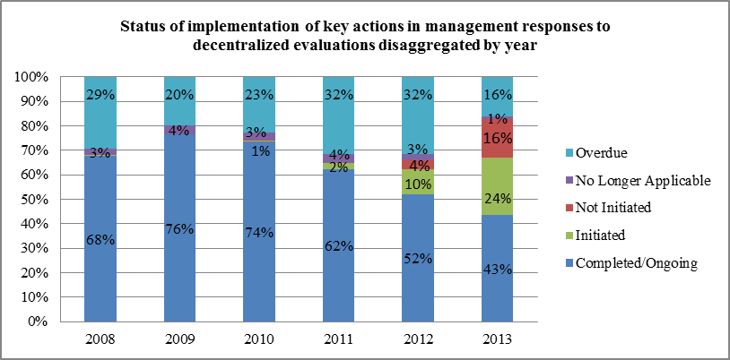

Figure 2: Status of key actions in management responses to decentralized evaluations, 2008-2013
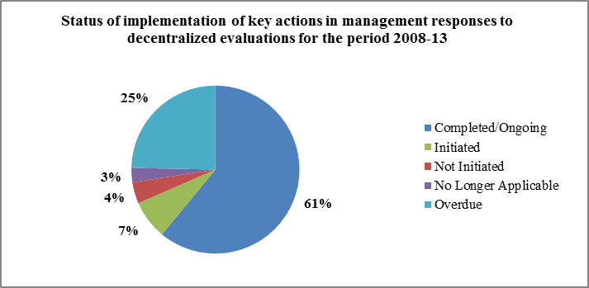
- Management notes that the 2008-2013 average rate of overdue management responses is significant (25 per cent) and makes a firm commitment to take action and lower that rate (figure 2).

Quality assessment of UNDP decentralized evaluations

- The annual report on evaluation noted a positive trend in the quality of evaluations. The analysis shows that 45 per cent of assessed evaluations were rated ‘satisfactory’ or better (compared to 32 per cent in 2012), 36 per cent ‘moderately satisfactory’ (compared to 43 per cent in 2012), and 19 per cent ‘moderately unsatisfactory’ or worse (compared to 25 per cent in 2012). UNDP management takes note that moderately unsatisfactory reports have been cut in half since 2011, and that the number of evaluations judged to be satisfactory has increased each year and now more than doubled in the same time period. UNDP management reaffirms its commitment to lower the rate of moderately unsatisfactory evaluations.

- It is important to highlight that the quality of decentralized evaluations has been increasing steadily since the quality ratings were first introduced. UNDP has identified critical factors triggering the improvement of quality and quantity of evaluations: (a) a consistent management demand and better use of evaluations; (b) better oversight and support by regional bureaus, resulting in improved adherence by country offices to evaluation plans and improved quality of evaluation management; and (c) accumulated experience in conducting evaluations (as per shown in figure 3 below, increasing numbers of evaluations across the organization would tend to demonstrate that with practice, UNDP is acquiring improved skills to conduct evaluations).

Figure 3 – Quality of decentralized evaluations vs. total number of decentralized evaluations
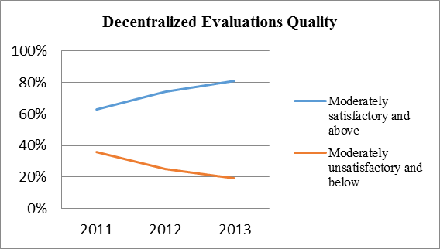

Coverage and use of evaluation

- UNDP continues to encourage improved functionalities in the ERC and a stronger learning-oriented dissemination strategy for evaluation findings and recommendations to serve stronger organizational learning and decision-making. As those discussions with IEO continue, UNDP has used the country office results-oriented annual report and a decentralized evaluation database to gather complementary data that the ERC does not provide, attempting to address such issues as evaluation coverage across outcomes, cross-referencing of findings, evaluation spending per Strategic Plan outcome and data on evaluation usage.

- Notably, in the 2013 results-oriented annual report, when asked to “indicate the most influential evaluations (UNDP or other) for [their] programme and specify the most significant changes they have catalyzed for national partners and for UNDP”, 135 country offices reported on 469 evaluations. Figure 4 below shows that a high proportion of those evaluations (72 per cent) were considered as a way to “strengthen dialogue with partners to inform more responsive programming”, while 54 per cent of those evaluations were believed to have “strengthened programmatic approaches and long-term and exit strategies to capacity development”. Fifty-three per cent of those evaluations were also considered by country offices as “a way to have more prioritized and focused programmes”, while 50 per cent were judged useful to “strengthen programme synergies, and strengthened RBM systems”. The types of evaluations that are cited the most are UNDP project evaluations commissioned by country offices (ADR citations coincide with the countries where they were conducted most recently).

Figure 4 – Use of evaluations by country offices 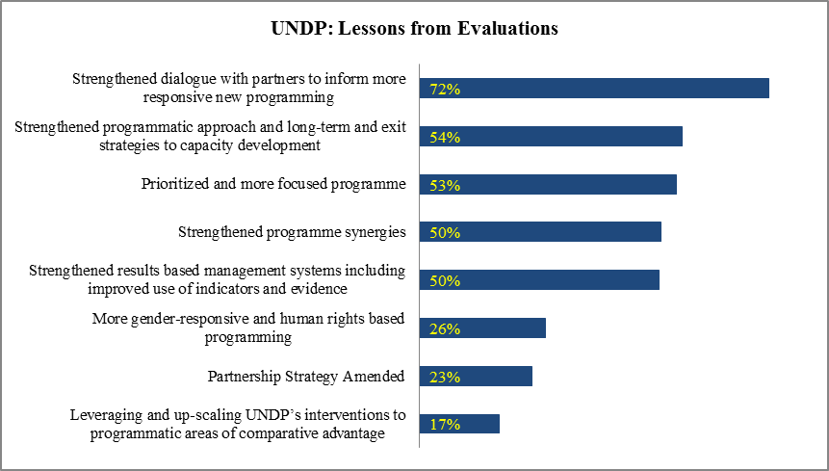

Challenges to evaluation quality

- UNDP management notes with interest the observations contained in the annual report on evaluation relating to challenges in evaluation quality. UNDP management particularly appreciates the more detailed feedback provided by the IEO on the component elements of the ratings system and the cause/effect relationships between those components. This will permit more targeted action to address shortcomings across the organization.

- Measures such as the regular discussion of evaluation matters at the highest governance levels of the organization, and the improvement of evaluation use and learning from evaluation findings are becoming common practice. UNDP is ensuring efforts are undertaken to stimulate the organization in this area. Good incentives include the provision for mandatory management responses to all evaluations that are monitored through the ERC; strengthening and greater visibility of the CPD quality assurance process that inter alia checks that countries are using evaluation learning to develop CPDs; and as of 2014, the requirement to set baselines, targets and milestones against IRRF indicators that is already driving the organization to be more evidence-based.

- Key measures of the evaluation policy approved by the Executive Board in 2011 have been helpful in driving a stronger culture of evaluation in the organization, such as the requirement to have fully costed evaluation plans in all CPDs and an increased focus on compliance. UNDP management looks forward to the findings of the 2014 review of the evaluation policy and to explore ways to further strengthen these approaches in the context of the next revision.

Quality of Global Environment Facility (GEF) terminal evaluations

- UNDP is pleased to note the strong quality of terminal evaluation reports of UNDP-supported, GEF-financed projects, with 75 per cent of the 2013 cohort of 44 reports assessed to be in the satisfactory range. While these quality ratings are similar to previous years, it is difficult to establish trends from year to year as the UNDP IEO guidance for GEF-financed terminal evaluations came into effect early in 2012, and terminal evaluations completed before 2012 were assessed using different quality criteria.

- The GEF IEO is expected to update its requirements for terminal evaluations in 2014 and as a result, the UNDP IEO guidance for GEF-financed terminal evaluations and the quality criteria will need to be revised accordingly. The GEF IEO regularly reviews the quality of M&E provided by UNDP and compares this performance to the other GEF implementing agencies. As noted in the 2013 GEF IEO Annual Performance Report (available at www.thegef.org) UNDP has the highest percentage of GEF-financed projects with M&E implementation ratings of moderately satisfactory or above, higher than UNEP and the World Bank.

- The process of undertaking a terminal evaluation of a GEF-financed project is managed by the UNDP country office, which engages an independent evaluator to assess the results achieved by the project. Quality assurance of the report before it is finalized is provided by the UNDP-GEF Regional Technical Advisor (RTA). In general, the RTA is accountable for the quality of M&E throughout the lifetime of the project as high quality M&E will help to deliver the desired project results. Backstopping is provided as necessary by a small UNDP-GEF RBM team. The UNDP and GEF quality requirements, along with detailed roles and responsibilities, are outlined in M&E guidance documents and standard templates for GEF-financed projects. These help to ensure that a strong M&E framework is embedded into the project cycle from the design phase to project closure. M&E training is provided during the Environment and Energy Community of Practice meetings, and the RTAs also provide regular updates and further training to UNDP country offices during project supervision missions.

Independent evaluations

- UNDP management underlines that similarly for decentralized and independent evaluations, the organization is undertaking sustained efforts to tackle the implementation of management response key actions. Management reaffirms its engagement to address the 20 per cent rate of overdue key actions.

Table 2 - Overview of the status of implementation of management responses for independent evaluations
Title | Mgmt. Response Status | No. of Key Actions | Completed/Ongoing | Initiated | Not Initiated | No Longer Applicable | Overdue
Assessment of Development Results: Angola | Yes | 18 | 16 | 2 | 0 | 0 | 0
Assessment of Development Results: Côte d'Ivoire | Yes | 6 | 3 | 0 | 0 | 0 | 3
Assessment of Development Results: Niger | Yes | 17 | 8 | 8 | 0 | 0 | 1
Evaluation of the Fourth Global Programme | Yes | 24 | 5 | 15 | 0 | 0 | 4
Evaluation of the Regional Programme for Africa (2008-2013) | Yes | 20 | 18 | 2 | 0 | 0 | 0
Evaluation of the Regional Programme for Arab States (2010-2013) | Yes | 12 | 9 | 3 | 0 | 0 | 0
Evaluation of the Regional Programme for Asia and the Pacific (2008-2013) | Yes | 22 | 10 | 7 | 0 | 0 | 5
Evaluation of the Regional Programme for Europe and the CIS (2011-2013) | Yes | 19 | 2 | 17 | 0 | 0 | 0
Evaluation of UNDP Contribution to Poverty Reduction | Yes | 15 | 3 | 3 | 0 | 0 | 9
Evaluation of UNDP Contribution to South-South and Triangular Cooperation (2008-2011) | Yes | 21 | 7 | 10 | 1 | 0 | 3
Evaluation of UNDP Regional Programme for Latin America and the Caribbean (2008-2013) | Yes | 17 | 5 | 11 | 0 | 0 | 1
Evaluation of UNDP Strategic Plan 2008-2013 | Yes | 11 | 9 | 2 | 0 | 0 | 0
Evaluation of UNDP Support to Conflict-Affected Countries in the Context of UN Peace Operations | Yes | 35 | 13 | 5 | 5 | 0 | 12
Totals 2013 | 8 | 219 | 92 | 83 | 6 | 0 | 38

Figure 5 – Status of key actions in management responses to independent evaluations (2013)
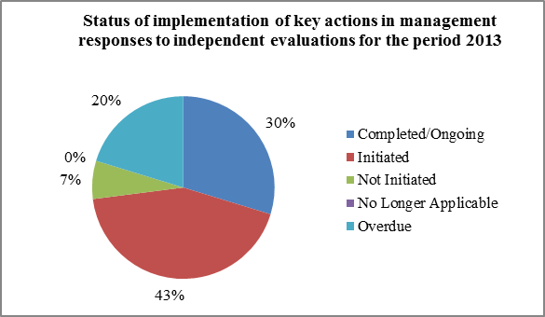

Associated funds and programmes

UNCDF

- Evaluation is a central function in UNCDF, ensuring the organization’s accountability for results and the incorporation of lessons learned in the development of new strategies and initiatives. While maintaining an active portfolio of independent evaluations, the Evaluation Unit continues to assist UNCDF to improve the quality of its programming. It supported the development of an updated results chain for the organization’s two programme areas, strengthening the correlation between the organization’s interventions and the development results they seek to influence. The accountability framework of the 2014-2017 UNCDF Strategic Framework, embodied in the IRRF, is based on principles of sound RBM that will facilitate objective monitoring and evaluation.

- UNCDF has learned from and incorporated recommendations from three evaluations. The midterm evaluation of the Youth-Start programme, which focuses on helping microfinance institutions deliver financial services for young people, found that the programme was progressing in accordance with set outcomes. However, the evaluation highlighted difficulties by financial service providers in attracting and providing services to young women and girls. UNCDF is now following up with measures to extend the reach of the programme by making better use of the UNDP and UNCDF network in Africa. Results for the Gender Equitable Local Development Programme were more mixed and UNCDF has now incorporated all the findings and recommendations of the evaluation in the design of a successor programme launched in early 2014. The evaluation of the local development programme in Liberia highlighted a series of missed opportunities for UNCDF and the findings will be incorporated in the planning of future similar interventions.

- In 2014, UNCDF will ensure that the Evaluation Unit has adequate resources to fulfil its mandate and that it keeps an active role in the monitoring of progress during the implementation of the Strategic Framework. The unit will be also responsible for the midterm review and final evaluation. While continuing to support UNCDF in ensuring qualitative improvements in the results chain of its interventions, the Unit will carry out four independent evaluations, reporting directly to the Executive Secretary.

UNV

- Evaluation continues to be an important priority for UNV and a key element of organizational learning, accountability and RBM. One key centralized evaluation initiated by UNV in 2013 is the Summative Evaluation of UNV Contribution to Volunteer Infrastructures – which was completed during the fourth quarter of 2014 – and will be reported on accordingly. This evaluation is critical for UNV, as it will inform the development of its new global programme on volunteer infrastructure - one of the five programme priority areas under the UNV strategic framework 2014-17. This programme area reflects a unique area of UNV support to programme countries and hence this evaluation is key to the future success of such programme interventions.

- Evaluation played a key role in the organizational reflections required to develop the new UNV strategic framework during 2013. The framework has prompted a reconsideration of the way in which evaluation is undertaken at UNV – and has provided a clear opportunity to reposition evaluation to better support delivery of results by UNV results. UNV has a unique mandate and function within the United Nations system, especially in supporting and working jointly with United Nations entities with UNV volunteers and volunteerism. As such, UNV will seek to work more closely with the evaluations by United Nations partners with a view to systematically measuring the contribution and differentiated impact of volunteer and volunteerism. It is expected that this would then contribute to the institutional knowledge of UNV that can be leveraged into relations with United Nations entities for UNV volunteer deployment and into new, improved and innovative joint programmes. During 2014-2015, it is expected that this new approach will be embedded in UNV and associated evaluation policies.

Conclusion

- Evaluations are critical to maintain a strong results focus and to continuously improve the quality of UNDP support to help countries tackle their development challenges. UNDP appreciates the continued efforts of IEO to increase the usefulness of its evaluations, and remains fully committed to further improve the quality, coverage and use of decentralized evaluations. Evaluations provide an important source of evidence of what works and what does not in different contexts, which is critical to maintain a strong focus on effectiveness, and to continuously improve the relevance of UNDP support.

Internal methodological notes for each indicator were developed to guide country offices on how to measure and explain the approach to aggregation and disaggregation of data.
28 November 2012 OPG meeting
The Executive Group is the most senior UNDP management group, is chaired by the Administrator and meets on average once a month. The Organizational Performance Group is the second most senior management group, is chaired by the Associate Administrator, and meets on average twice a month.
The OPG regularly reviews all independent global thematic evaluations and management responses, monitors evaluation compliance and implementation rates of management responses, periodically reviews organizational progress on programme quality and results reporting performance indicators, and conducts semi-annual discussions of emerging and recurring findings from independent evaluations.
All references to Kosovo in this report should be understood to be in the context of United Nations Security Council resolution 1244 (1999).
Meeting report available at: https://undp.unteamworks.org/node/408351
?The CoP works through meetings, trainings, Webinars, newsletters (3 newsletters in 2013) and emailing list: https://undp.unteamworks.org/node/17347
Source: Annual reports on evaluation 2011, 2012, 2013
Source: Evaluation Resource Centre, 1March ^{t} 2014

